Mr. Sabado, Pre-Algebra Wednesday, October 30, 2013

Homework

Due Today:
-No HW

Due 10/31:
-Page 117: 1-40, 42-53

Chapter 2 Test on Thursday!!!

Agenda

- Warm-Up

- Review Continued: Chapter 2 Review Stations

- Homework

- Return Graded Work


Warm-Up

Simplify
- 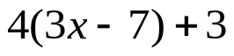

Name the property shown.
2) 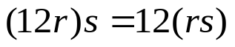


whs.saba.do

“It is never too late to be what you might have been.”
- G. Eliot

